EXPERIEMNT-15

Demonstrate Platform as a Service (PaaS) create and configure a new VM Image in any Public Cloud Service Provider.

STEP 1: GO TO THE CREATE AND SELECT THE AZURE VIRTUAL MACHINE.

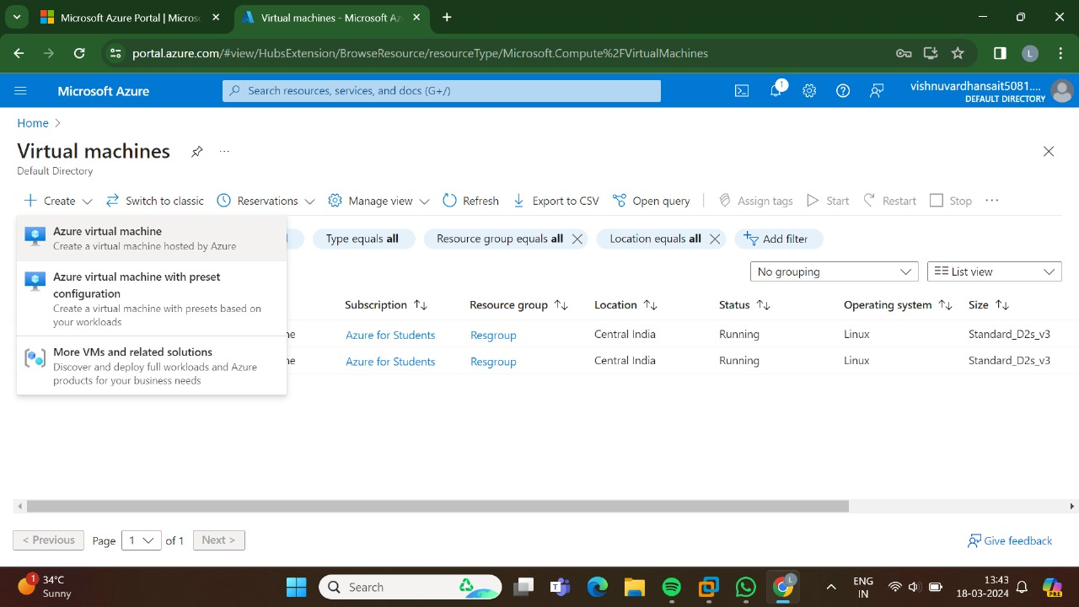

STEP:2:THEN,GO FOR THE BASICS.

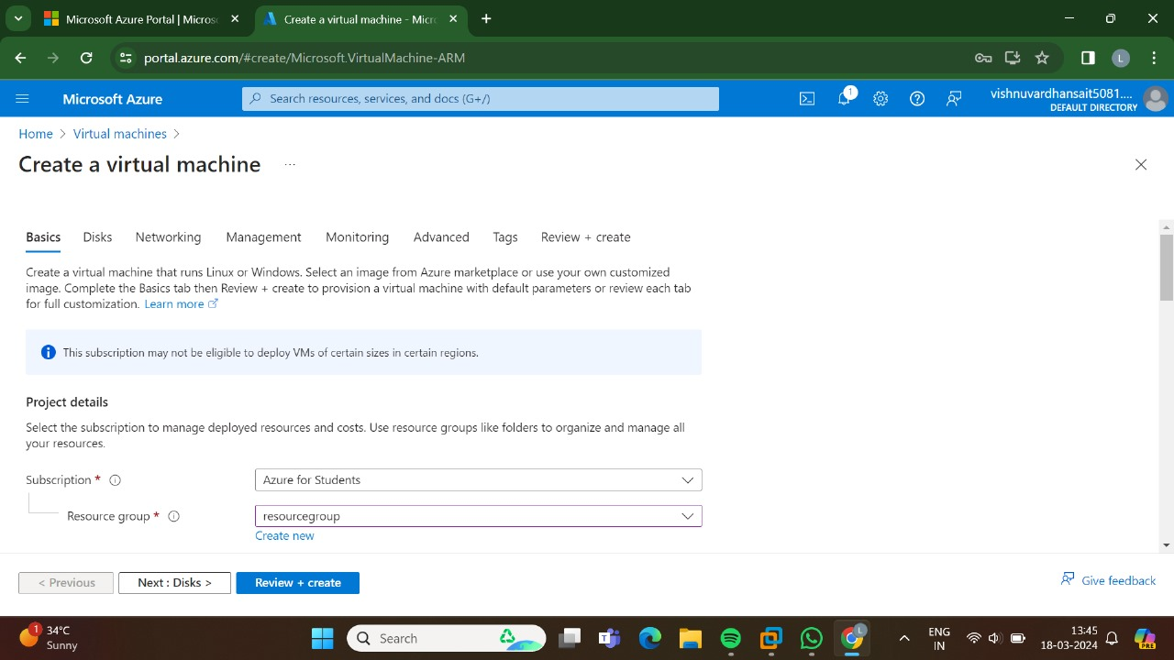

STEP:3:AND, THEN GO FOR THE DISKS.

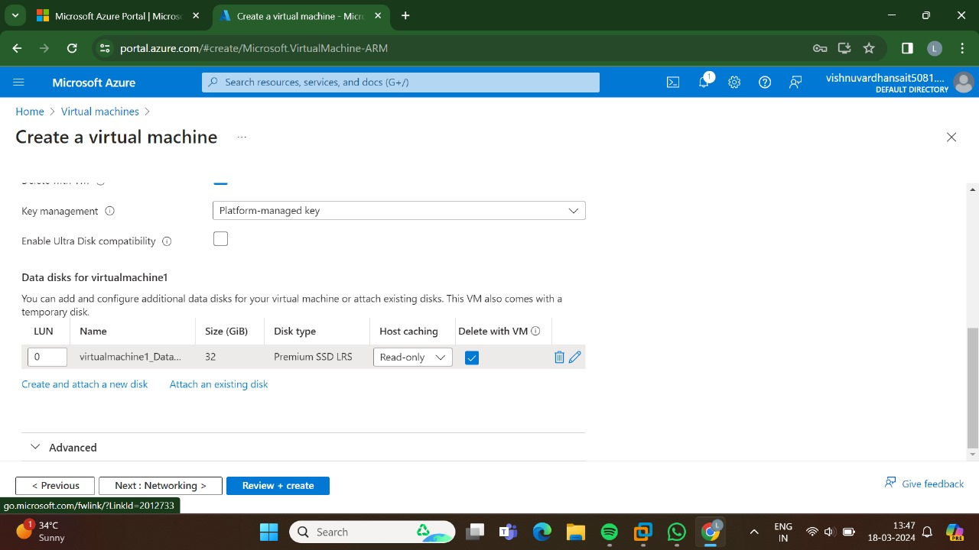

STEP:4:AND THEN GO FOR THE NETWORKING.

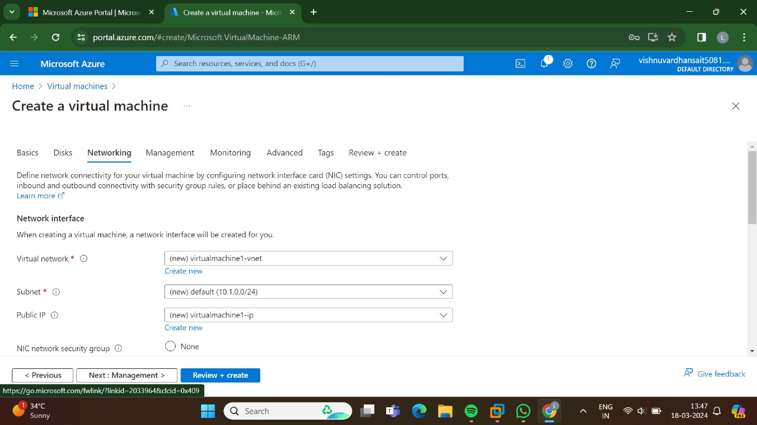

STEP:5:AND, THEN GO FOR THE MANAGEMENT.

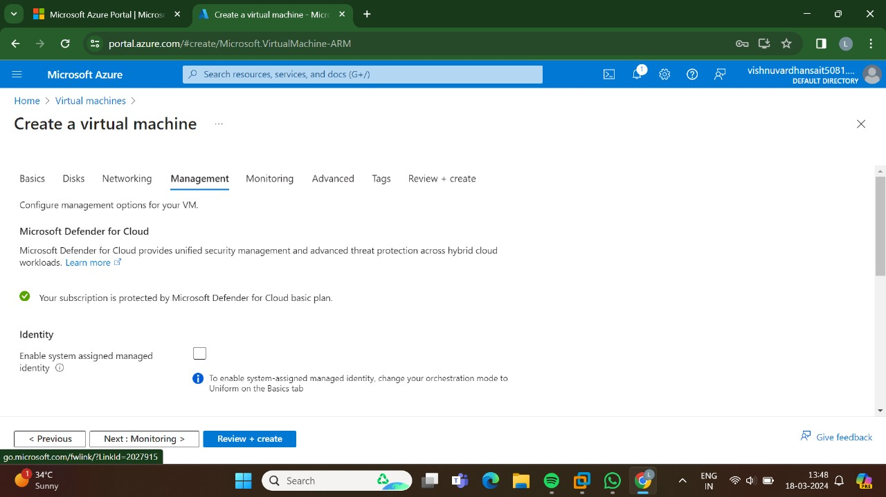

STEP:6: AND, THE GO FOR THE MONITORING.

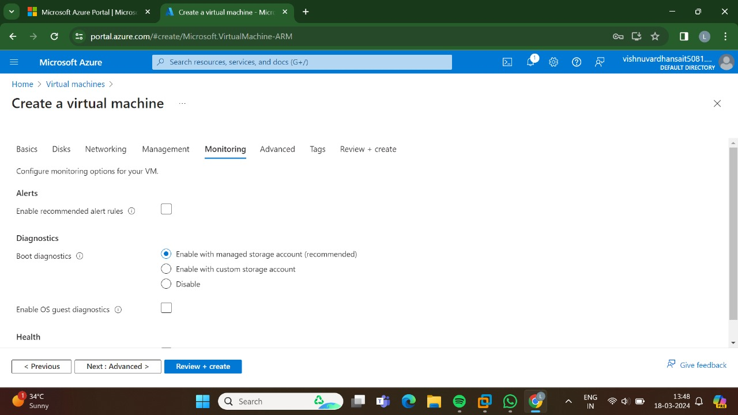

STEP 7: AND THEN GO FOR THE ADVANCED.

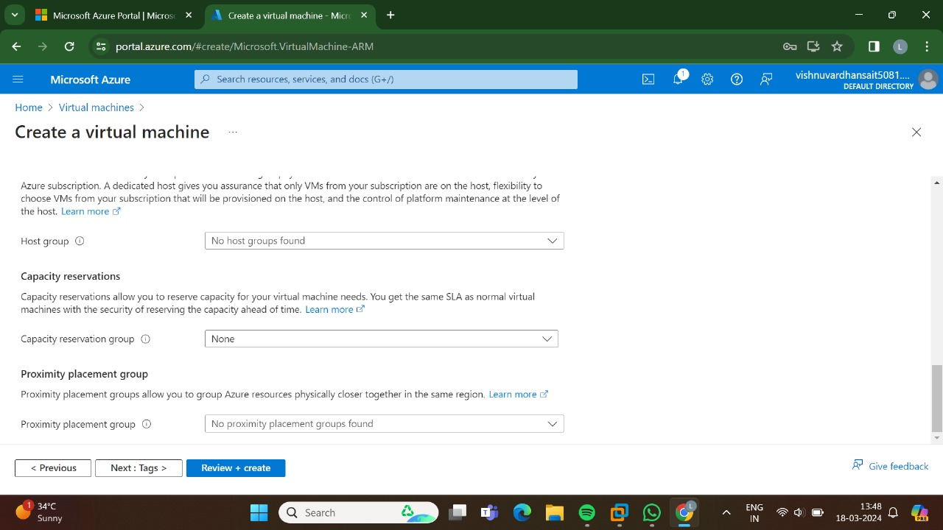

STEP:8:: AND,THEN GO FOR THE TAGS.

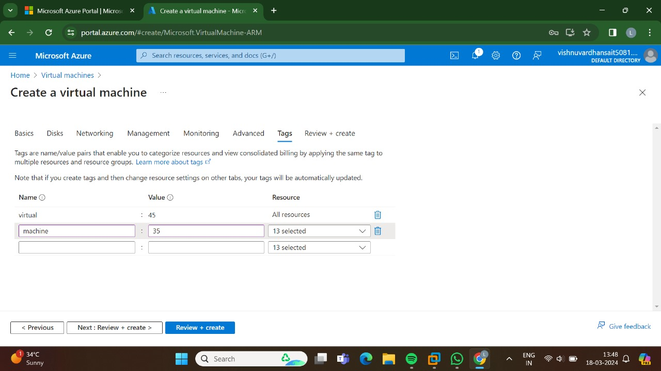

STEP:9:: AND, THEN GO FOR THE REVIEW+CREATE AND THEN GO FOR THE CREATE.

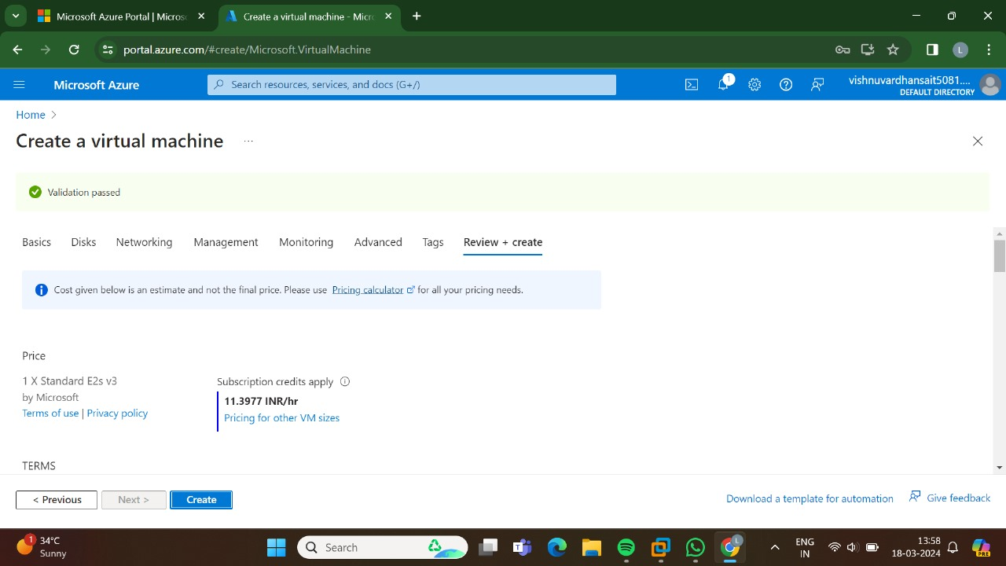

STEP:10:THE, DEPLOYMENT IS INPROGRESS.

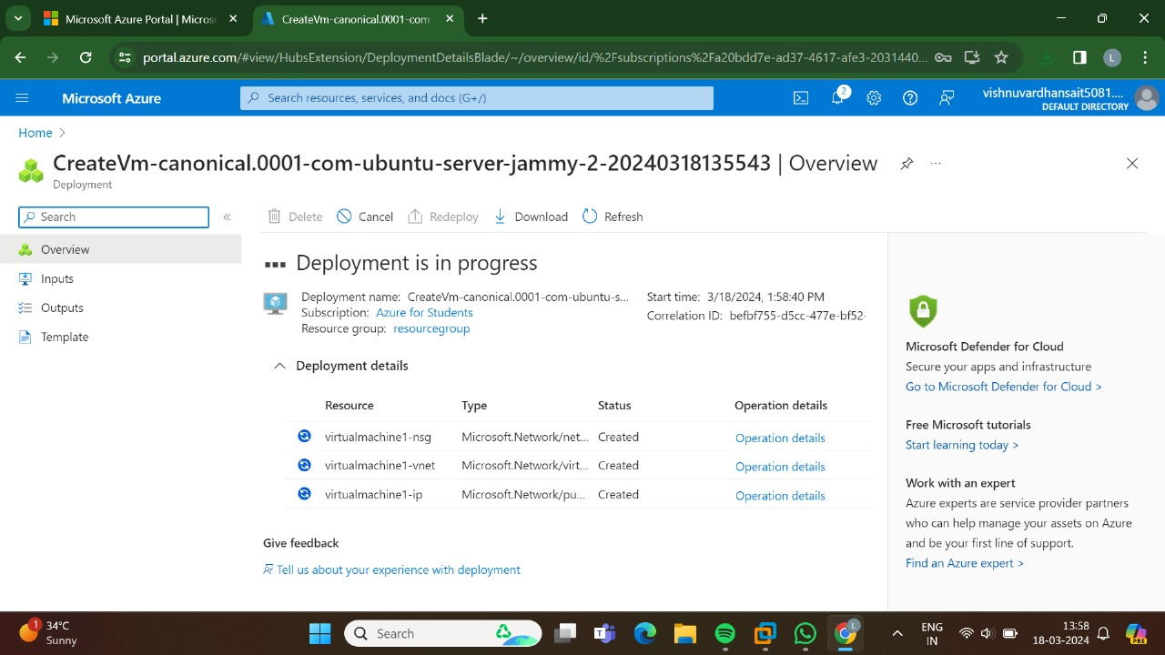

STEP:11:HENCE, THE DEPLOYMENT HAS BEEN COMPLETED SUCCESSFULLY.

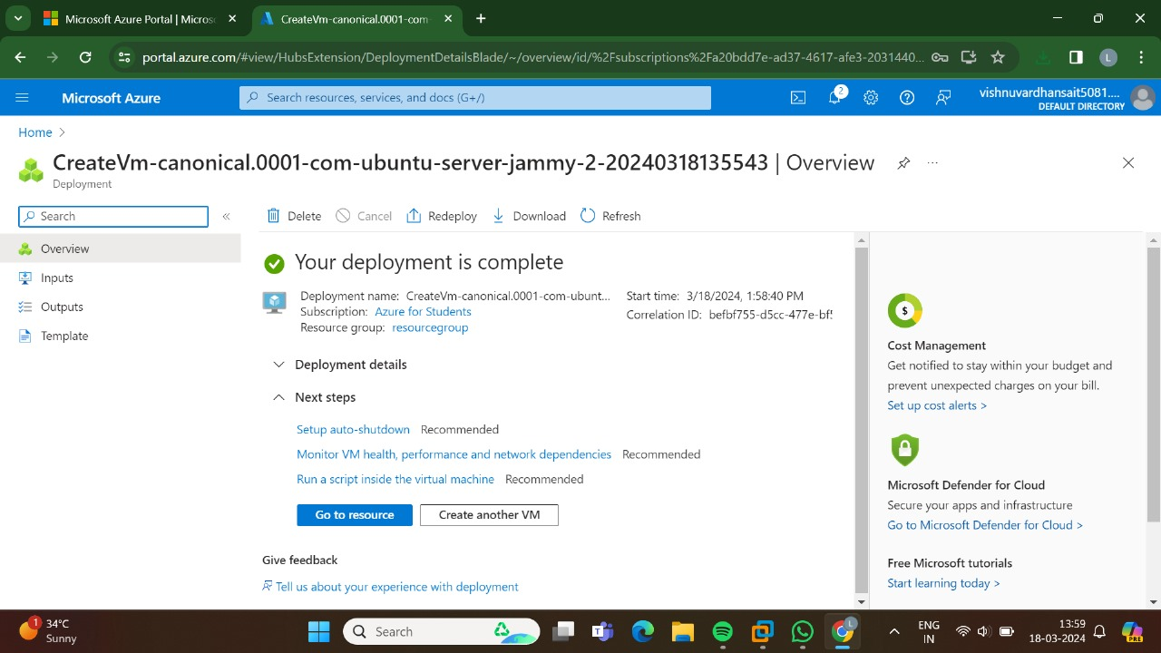

RESULT:THUS ,THE PROGRAM HAS BEEN EXCEUTED SUCCESSFULLY.